**Date Object in JavaScript**

**Introduction**

Date object is used to store date & time information and return them in any time we need.

There are two different ways in which time is measured:

1. **Global (World) time:** It’s a standard time for all countries around the world.
2. **Local (Zonal) time:** It different from one country to another depending on time zone of the country.

Example:

If now the global time is 12hrs then for everyone in this world the time will 12hrs no matter in which time zone they are located. Whereas the local time differs for everyone based on the time zone in which they are located.

**GMT (Greenwich Mean Time):**

GMT is used to measure time based on prime meridian line and divides the globe in time zones. Prime meridian line is the 0 degree longitude line that divides the globe in half; it passes through Greenwich area, London.

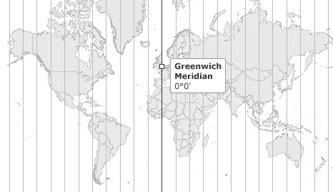

Glob map is divided into different regions, based on GMT. There is 'n' number of zones ahead (right) or behind (left) GMT line, each zone has a specific time so these zones are known as “time zones” or “Local time standards”.

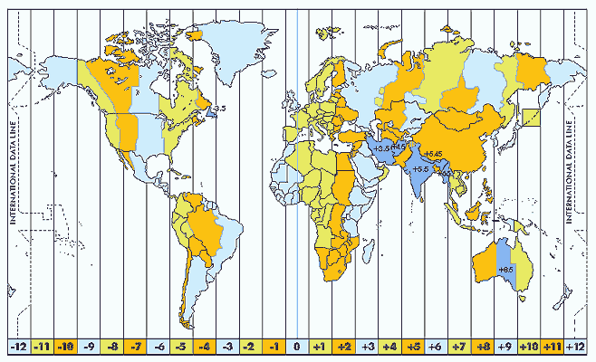

**Example:**

We know that Local time differs based on time zone. In the 0th time zone if local time is 0 AM then in the +5 time zone the local time will be 5AM because +5 time zone indicates the local time is 5 hours ahead of GMT. So As London falls under 0th time zone if local time is at London is 0AM, then in Egyptain local time will be 2AM as it falls +2 time zone ahead GMT line.

UTC (GMT): Global / World's time standard.

UTC stands to “Coordinated Universal Time” and it’s formerly known as GMT.

UTC represents 24 hour time standard measures time precisely (one day). UTC+[00:00](https://www.youtube.com/watch?v=Qy8nvsTsWUk&list=PLdE8ESr9Th_seeZTebEFavp257vds9ph5&index=99&t=0s) is equivalent to GMT+[00:00](https://www.youtube.com/watch?v=Qy8nvsTsWUk&list=PLdE8ESr9Th_seeZTebEFavp257vds9ph5&index=99&t=0s) as UTC and GMT is the same thing.

**Example:**

Egypt Standard Time is used to observe date time in Egypt, with a time offset of GMT+[02:00](https://www.youtube.com/watch?v=Qy8nvsTsWUk&list=PLdE8ESr9Th_seeZTebEFavp257vds9ph5&index=99&t=330s).

**Now.** UTC+05:11 AM === GMT+05:11 AM === GMT+07:00 in Egypt.

**Note:** Based on the time zone, the local time differs from GMT by the number of hours ahead or behind.

**Creating date in JavaScript**

We can create date objects using **Date constructor function** in different ways**.** In all ways we use variable to store current local date & time of country in the memory location of the date Object Name. So we can invoke them by using it.

**First way:**

In this way the parentheses is empty and date here is changeable

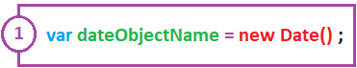

**Example 1:** this date is changeable date.

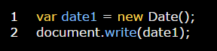

**Example 2:** in this example we write the date in a string shape by using .toString(). This date is also a changeable date

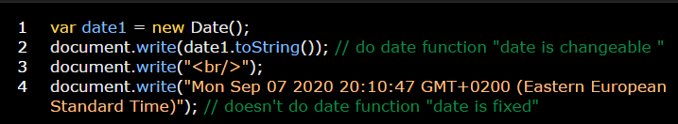

**Example 3:** in this example we write the date without +0200 (Eastern European Standard Time) part by using .toUTCString() method.

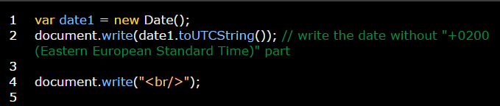

**Second way:**

In this way the parentheses contains the date as a string value so date here is fixed.



**Note:** we can use string date (fixed one) when we need to determine the date of publishing a specific article or anything else.

**Example 1:**

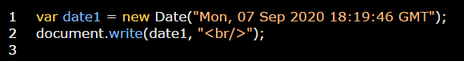

**Third way:**



**Example 1:**



**Fourth way:**



This way is used to create a date object using time in milliseconds.

**Note:** Date object stores date & time based on the numbers of milliseconds elapsed from Thu, 01 Jan 1970 [00:00:00](https://www.youtube.com/watch?v=xYtuBOD-oAI&list=PLdE8ESr9Th_seeZTebEFavp257vds9ph5&index=100&t=0s) GMT.

**Example:**

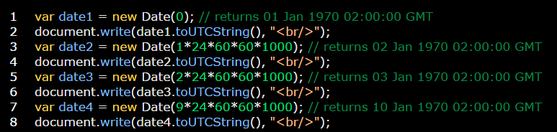

You can use .getTime method with all four ways to return changeable and fixed milliseconds.

**Example:**

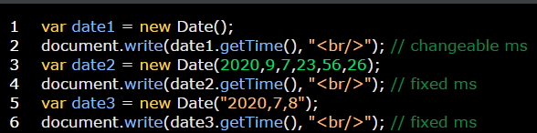

**Displaying Date in different formats**

1. **getTime();**

Returns the number of milliseconds elapsed since midnight January 1, 1970, universal time.

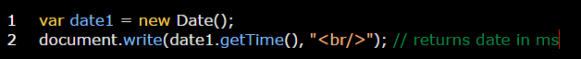

1. **getTimezoneOffset();**

This method is used to get the difference between the global time (GMT) and your local time in minutes. GMT – local time =differ time in minutes

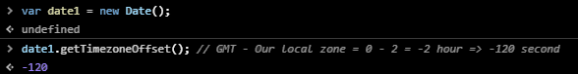

1. **toString();**

This function is used to convert the date (object) to a string data type.

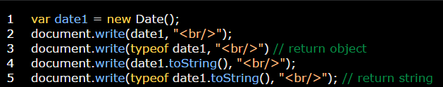

1. **toUTCString();**

This function is used to return the date without local zone of your area.

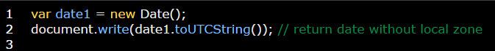

1. **toDateString();**

This function is used to appear only date of time without local zone and time.

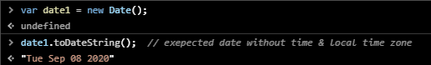

1. **toTimeString();**

This method is used to appear only time of day without the date and local time zone.

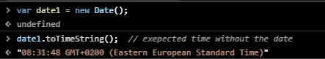

1. **toLocalString();**

This function is used to appear date and time of a specific local zone.

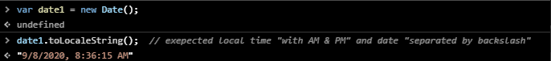

1. **toLocaleDateString();**

This function is used to appear local date only.

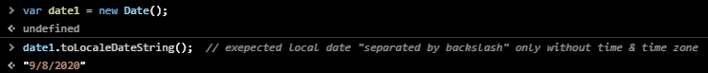

1. **toLocaleTimeString();**

This function is used to appear local time of day only.

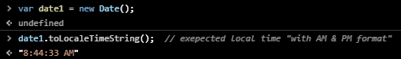

1. **toISOString**

This method is used to convert the date syntax from the complete one to Iso syntax to make it more readable.

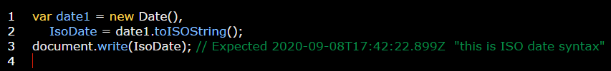

1. **Date.now();**

This method is used to return the period from 1970 till now in milliseconds.

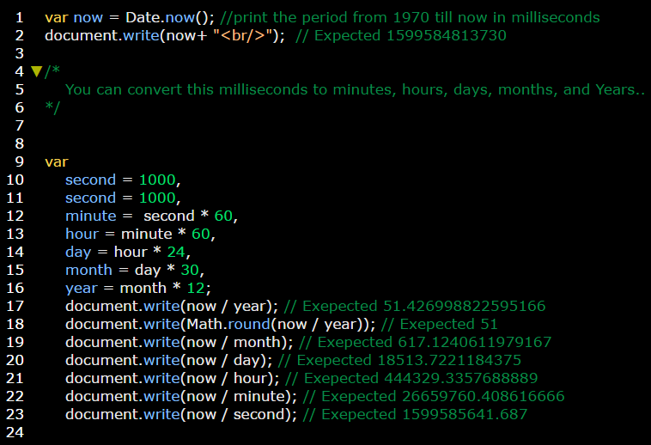

1. **Date.parse(“specific date”);**

This method is used to return the period from 1970 till a specific date in milliseconds.

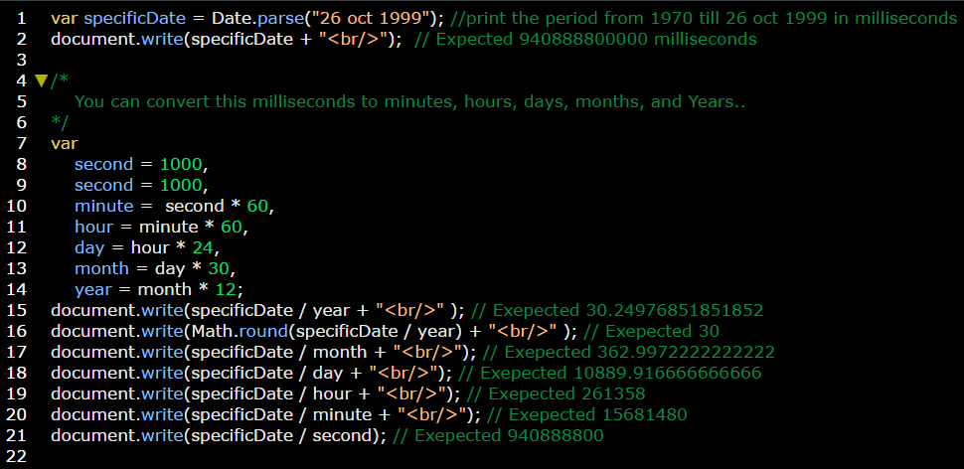

Some important Notes on JS date:

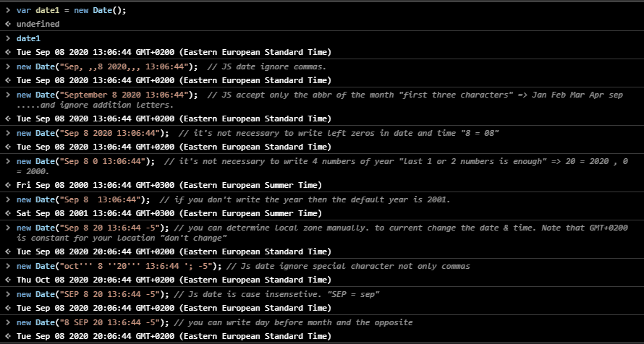

**Getter and Setter methods of date Object**

[Getter date methods.docx](Getter%20date%20methods.docx) are some methods used to get a specific parameters from the (local or GMT) date.

[Setter date methods.docx](Setter%20date%20methods.docx) are some methods used to set (modify) a specific parameters from the (local or GMT) date